Chess Academy Website
Website Planning & Documentation

1. Website Overview
1.1 Website Objectives
The main objective of the Chess Academy website is to provide a platform where users can learn and improve their chess skills. The website aims to encourage more people to take an interest in chess by offering structured lessons, interactive practice tools, and access to real-world chess communities.
It is designed to support both beginners and intermediate players by combining educational content with practical learning. This approach allows users to not only understand the concepts but also apply them, similar to how organisations like FIDE promote and grow interest in chess.

1.2 Target Audience
The website is aimed at beginner and intermediate chess players, as well as individuals who are interested in learning the game or improving their existing skills.
Demographics:
- Ages 13–45 (students and working professionals)
- Users with basic digital skills
- Individuals interested in chess as a hobby or competitive activity
The website is designed to be simple and easy to use, ensuring that both new and experienced users can navigate it without difficulty.

1.3 Type of Website
The Chess Academy website is an educational and training platform focused on chess development.
It provides:
- Structured lessons on openings, middlegame, and endgame strategies
- Embedded video content to support learning
- An interactive chessboard for practising moves
- Information about chess clubs and tournaments
By combining both learning and practical elements, the website creates a complete environment for developing chess skills.

2. Information Architecture
2.1 Content Organization
The website content is divided into the following main sections:
- Home – The main entry page
- Learn Chess – Tutorials and structured lessons
- Practice Tools – Interactive chess tools
- Community – Local clubs and tournament information
- Contact & Feedback – User communication
This structure makes it easy for users to find what they are looking for.
2.2 Sitemap
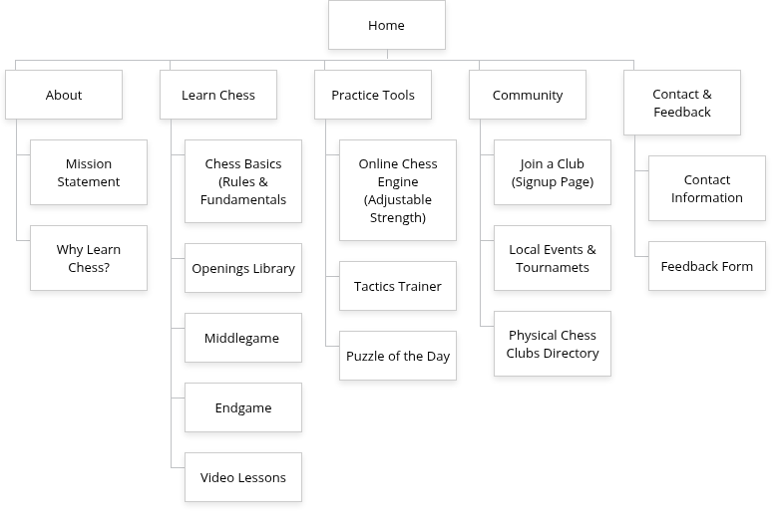
2.3 Navigation Structure
The website uses a navigation bar that is visible on all pages. This allows users to move easily between sections.
Main navigation includes:
- Home
- Learn Chess
- Practice Tools
- Community
- Contact & Feedback
This ensures a smooth and user-friendly browsing experience.
2.4 Flowchart / Storyboard
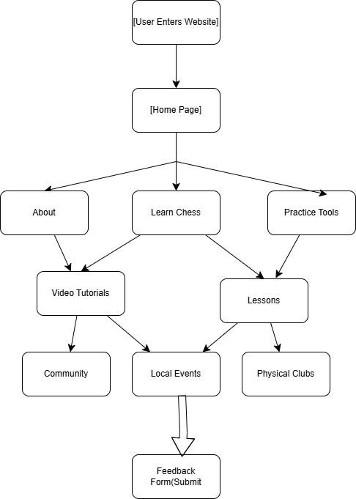
3. Page Template Design

3.1 Home Page
Layout Description
The Home page introduces users to the website and highlights the main features.
Structure:
- Navigation bar at the top
- Hero section with a call-to-action button
- Three feature cards (Learn, Practice, Community)
- Information section
- Footer
Wireframe:
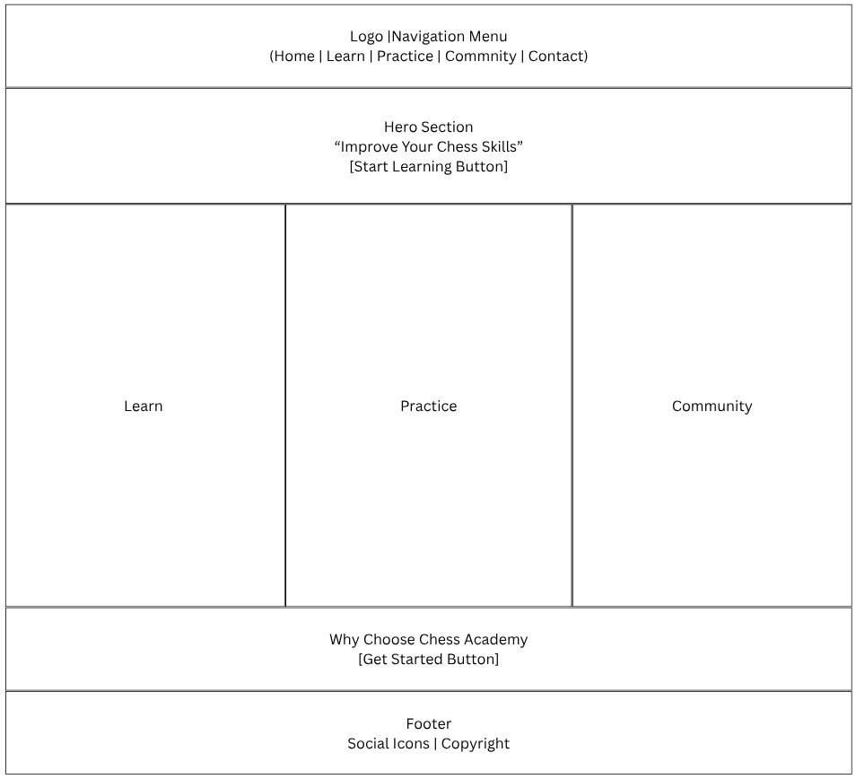
The wireframe shows the layout of the homepage, including the navigation bar, hero section, feature cards, and footer. It focuses on guiding users to the main sections of the website.
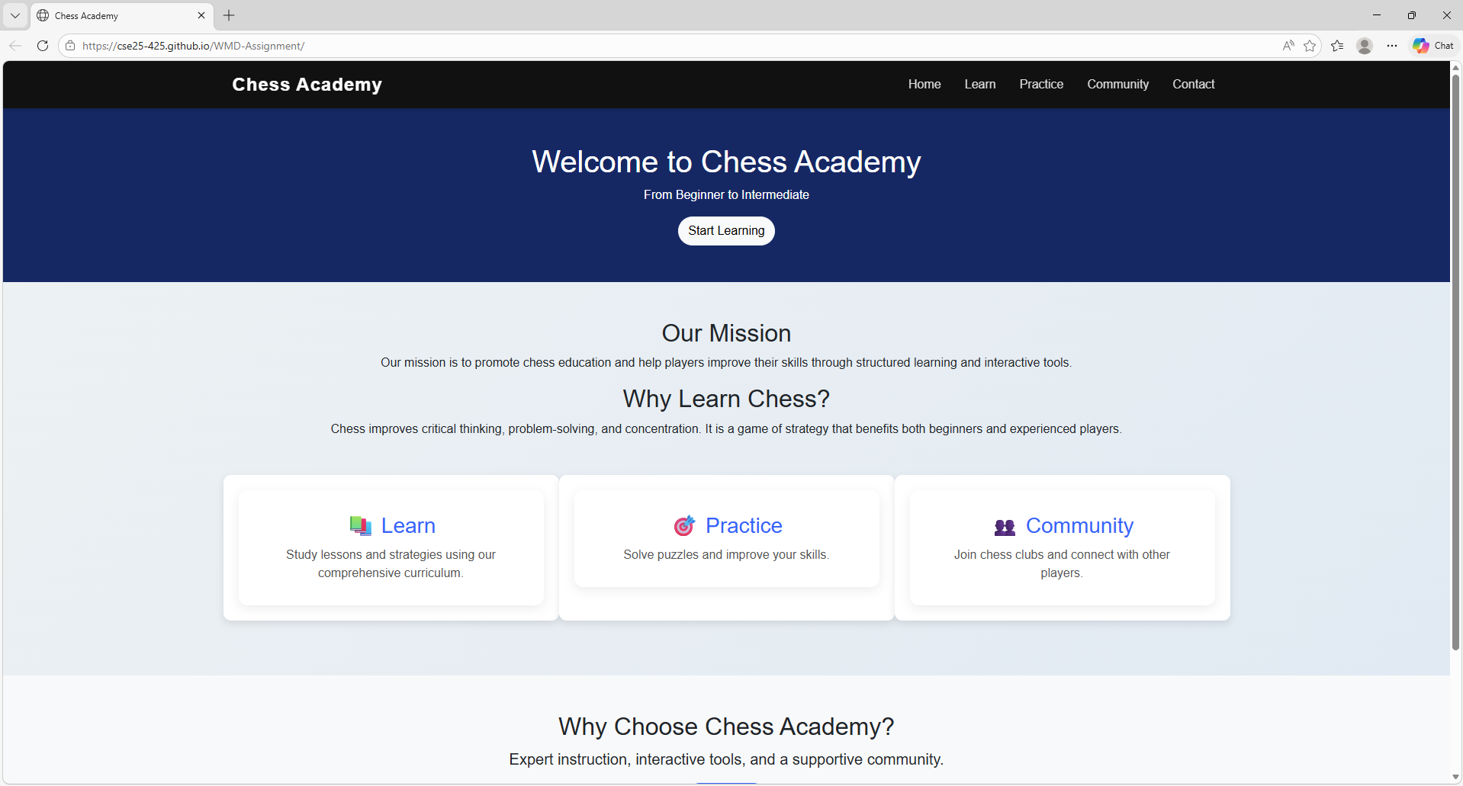
Figure 1: Home Page Wireframe
3.2 Learn (Tutoring) Page
The Learn page provides structured educational content, including:
- Chess basics
- Openings
- Middlegame strategies
- Endgame techniques
- Video lessons
The content is organised clearly to improve understanding.
Wireframe:
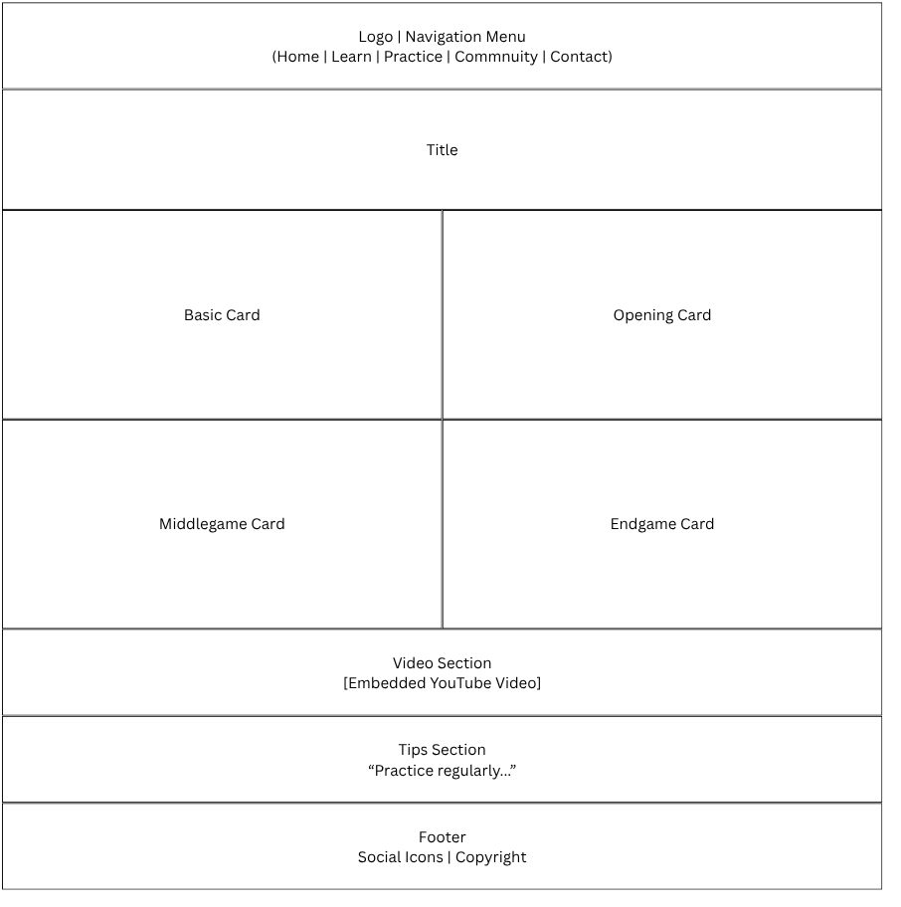Figure 2: Learn Page Wireframe
This page is designed like a course layout, allowing users to go through different topics in an organised way.
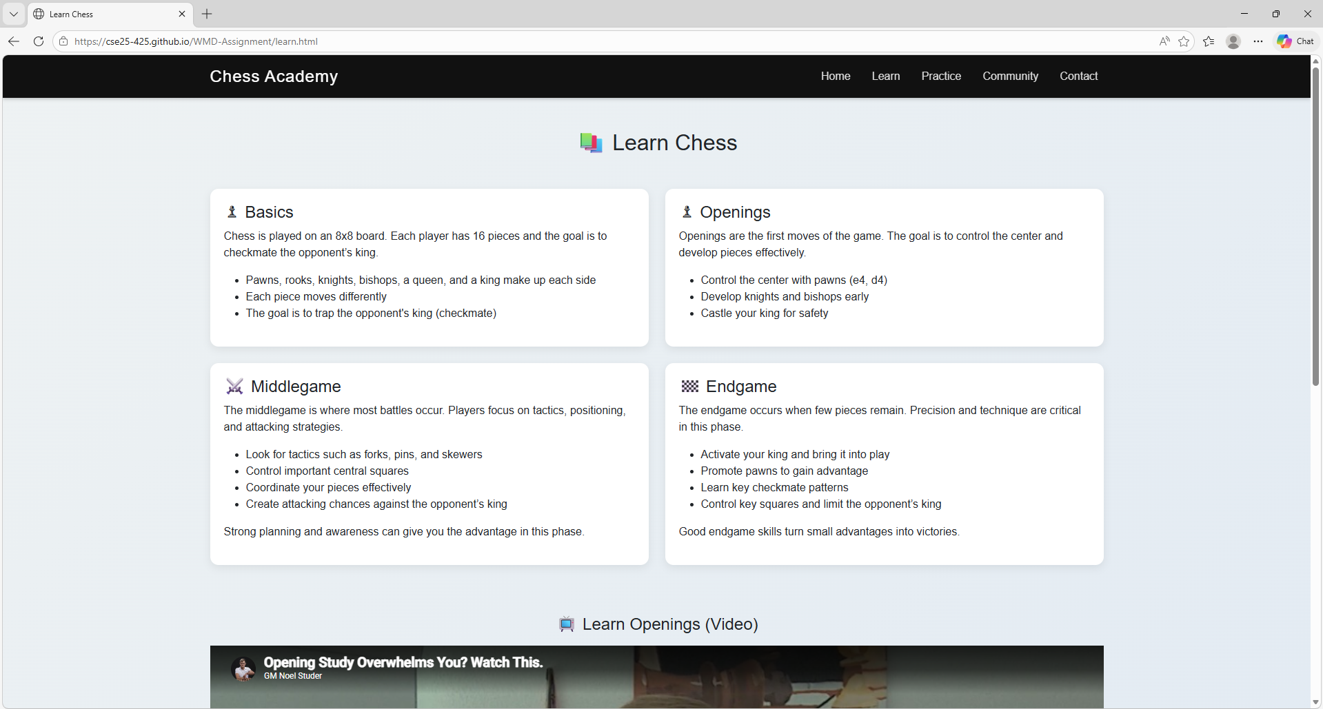
3.3 Practice Tools Page
Layout Description
This page allows users to practise chess using interactive features.
Features:
- Interactive chessboard
- AI opponent
- Legal move validation
- Highlighting of possible moves
Wireframe:
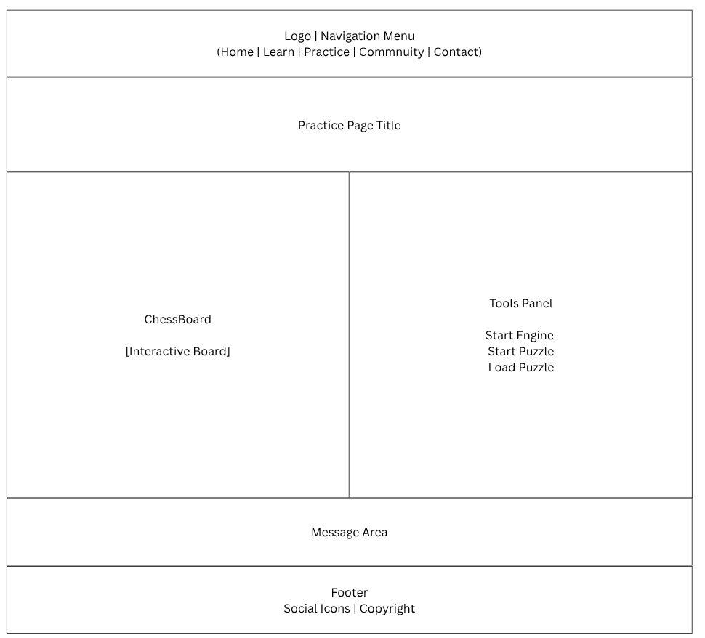Figure 3: Practice Page Wireframe
The layout focuses on interaction, with the chessboard as the main feature and control tools placed alongside it.
3.4 Community Page
This page includes:
- Information about local chess clubs
- Tables showing club details
- Tournament listings
Wireframe:
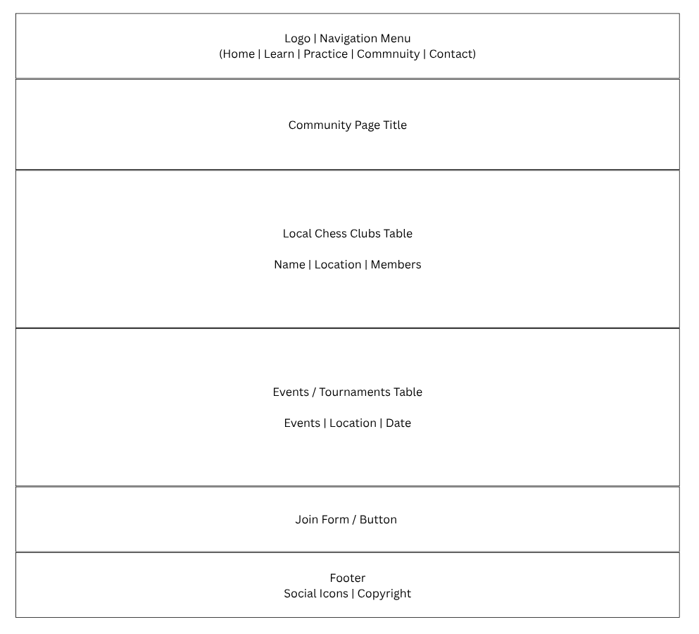Figure 4: Community Page Wireframe
The design encourages users to connect with real-world chess activities.
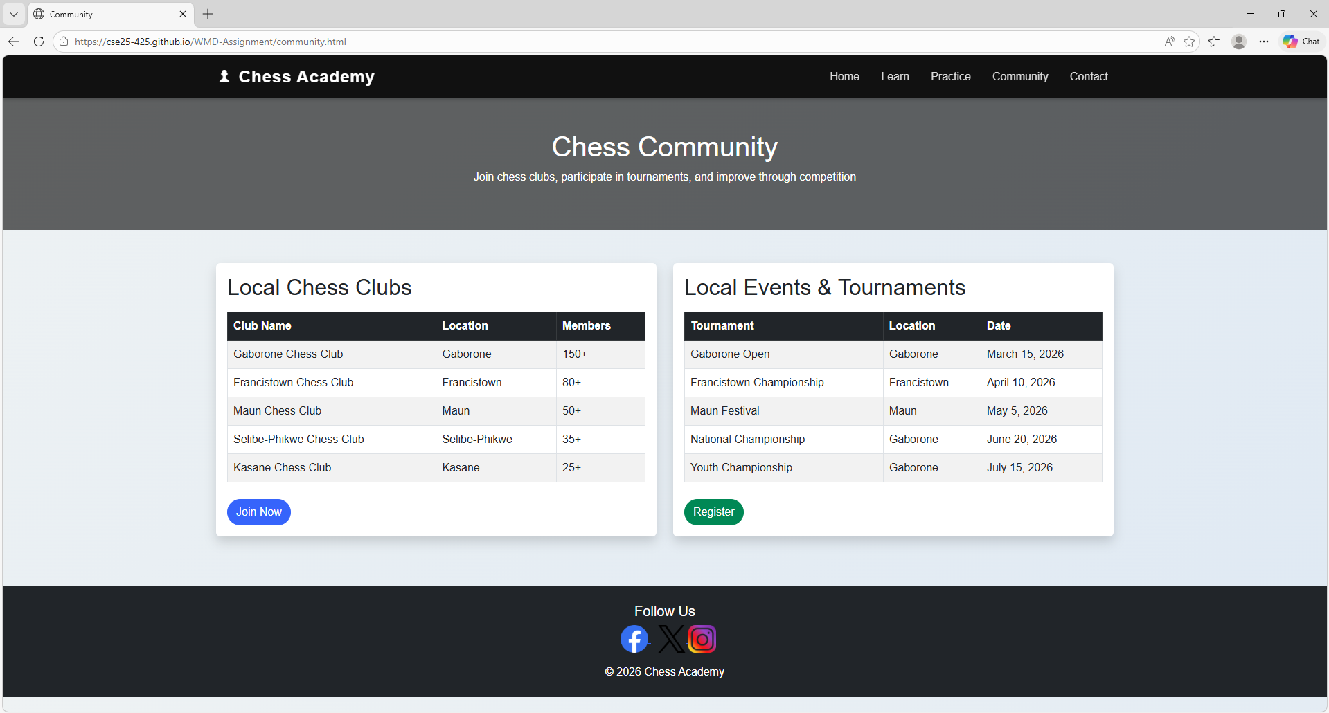

3.5 Contact & Feedback Page
This page allows users to:
- View contact details
- Submit feedback using a form
Wireframe:
(Insert Contact Page wireframe)
Figure 5: Contact Page Wireframe
The layout is simple, making it easy for users to communicate with the website.

The final website closely follows the wireframe designs, with small improvements made to enhance usability and visual appearance, such as the use of modern card layouts.

4. Development Technologies
4.1 Web Technologies
HTML5
- Used to structure the website
CSS3
- Used to style the layout and appearance
JavaScript Used to add interactivity, such as:
- Chessboard functionality
- Move validation
- Highlighting moves
- Form handling

4.2 Frameworks and Libraries
Bootstrap 5
- Helps with responsive design
- Provides ready-made components such as buttons, cards, and navigation bars
Chessboard.js
- Displays the chessboard
Chess.js
- Handles game logic and rules
Stockfish.js
- Provides an AI opponent

4.3 Software & Tools
Visual Studio Code
- Used to write and test code
Git & GitHub
- Used for version control and project hosting
Canva
- Used to design graphics and wireframes

5. Justification of Features
The features included were chosen to improve both learning and interaction.
The Practice page includes an interactive chessboard that allows users to try moves in real time. Chess.js ensures that only legal moves are allowed, while Stockfish provides an AI opponent.
The Learn page presents information in a structured way, making it easier to understand chess concepts. Videos are included to improve learning.
The Community page helps users find clubs and events, encouraging participation.
The Contact page allows users to send feedback and improve interaction with the website.

6. Testing
The website was tested to ensure everything works correctly.
Functional Testing:
- Navigation links were checked
- Chessboard movements were tested
- Illegal moves were rejected
- AI responses were verified
- Forms were tested

Responsiveness Testing:
- Tested on mobile, tablet, and desktop using browser tools

Browser Testing:
- Google Chrome
- Microsoft Edge
- Mozilla Firefox

7. Conclusion
In conclusion, the Chess Academy website successfully combines learning, practice, and community features into one platform.
The use of HTML, CSS, Bootstrap, and JavaScript allowed for the creation of a responsive and interactive website. Features such as the chessboard, AI opponent, and structured lessons improve user experience.
Overall, the project demonstrates a good understanding of web development and provides a strong foundation for further improvements.

